NUCL 510 HMWK 3

1. Mono-Energetic Neutron Beams Crossing
$$I_{beam}=ϕ_{beam}=5*{10}^{8}\frac{n}{cm^{2}s}$$

$$I_{intersection}=I_{beam}+I_{beam}=ϕ_{intersection}=1*{10}^{9}\frac{n}{cm^{2}s}$$

$$J_{Intersection,n1} is current normal to surface emitting beam 1 within the area of intersection$$

$$J_{1,n1}is the current of beam 1 normal to surface emitting beam 1$$

$$J_{Intersection,n1}=J_{1,n1}+J_{2,n1}=\int_{4π}{dΩΩψ_{1,n1}+\int_{4π}{dΩΩψ_{2,n1}}}$$

$$n_{1} is normal to surface emitting beam 1, e_{1} is parallel to surface emitting beam 1$$

$$ψ_{1}=ϕ_{beam}{\overset{⃑}{n}}_{1}+0{\overset{⃑}{e}}_{1}$$

$$ψ_{2}=ϕ_{beam}{\overset{⃑}{n}}_{2}=ϕ_{beam}\left({\overset{⃑}{n}}_{1}\cos\left({45}^{o}\right)\right)+ϕ_{beam}\left({\overset{⃑}{e}}_{1}\sin\left({45}^{o}\right)\right)=ϕ_{beam}\frac{\sqrt{2}}{2}{\overset{⃑}{n}}_{1}+ϕ_{beam}\frac{\sqrt{2}}{2}{\overset{⃑}{e}}_{1}$$

$$J_{Intersection,n1}={\overset{⃑}{n}}_{1}∙ψ_{1}+{\overset{⃑}{n}}_{1}∙ψ_{2}={\overset{⃑}{n}}_{1}∙ϕ_{beam}{\overset{⃑}{n}}_{1}+{\overset{⃑}{n}}_{1}ϕ_{beam}\frac{\sqrt{2}}{2}{\overset{⃑}{n}}_{1}$$

$$J_{Intersection,n1}=ϕ_{beam}+ϕ_{beam}\frac{\sqrt{2}}{2}=\frac{2+\sqrt{2}}{2}ϕ_{beam}=\frac{2+\sqrt{2}}{2}\left(5*{10}^{8}\right)=8.5355*{10}^{8}\frac{n}{cm^{2}s}$$

2. Density Distribution Functions of Mono-Energetic Neutrons
   1. Neutron Density
 $$n\left(\overset{⃑}{r},\overset{⃑}{Ω}\right)=ne^{-\frac{χ}{λ}}\left(1+\cos\left(θ\right)\right)$$

 $$n\left(\overset{⃑}{r}\right)=\int_{0}^{2π}{\int_{0}^{π}{ne^{-\frac{χ}{λ}}\left(1+\cos\left(θ\right)\right)\sin\left(θ\right)dθ}dϕ}=ne^{-\frac{χ}{λ}}\int_{0}^{π}{1+\cos\left(θ\right)dθ}\int_{0}^{2π}{\sin\left(θ\right)dθ}$$

 $$n\left(\overset{⃑}{r}\right)=4πne^{-\frac{χ}{λ}}$$

2. Neutron Flux
 $$ψ=v\left(E\right)n\left(\overset{⃑}{r},\overset{⃑}{Ω}\right)$$

 $$v\left(E\right)=v because neutrons are mono-energetic$$

 $$ψ=vn\left(\overset{⃑}{r},\overset{⃑}{Ω}\right)=vne^{-\frac{χ}{λ}}\left(1+\cos\left(θ\right)\right)$$

$$ϕ=\int_{4π}{d\overset{⃑}{Ω}}ψ\left(\overset{⃑}{r},E,\overset{⃑}{Ω},t\right)=4πvne^{-\frac{χ}{λ}}$$

3. Neutron Current
$$\overset{⃑}{J}\left(\overset{⃑}{r},E,t\right)=\int_{4π}{\overset{⃑}{Ω}ϕdΩ}={\overset{⃑}{e}}_{x}\int_{0}^{2π}{\int_{0}^{π}{rsinθcosϕ}}ne^{-\frac{χ}{λ}}\left(1+\cos\left(θ\right)\right)dθdϕ+{\overset{⃑}{e}}_{y}\int_{0}^{2π}{\int_{0}^{π}{rsinθcosϕ}}ne^{-\frac{χ}{λ}}\left(1+\cos\left(θ\right)\right)dθdϕ+{\overset{⃑}{e}}_{z}\int_{0}^{2π}{\int_{0}^{π}{rcosθ}}ne^{-\frac{χ}{λ}}\left(1+\cos\left(θ\right)\right)dθdϕ$$

$$\overset{⃑}{J}={\overset{⃑}{e}}_{x}\int_{0}^{2π}{cosϕdϕ\int_{0}^{π}{rsinθ}}ne^{-\frac{χ}{λ}}\left(1+\cos\left(θ\right)\right)dθ+{\overset{⃑}{e}}_{y}\int_{0}^{2π}{sinϕdϕ\int_{0}^{π}{rsinθ}}ne^{-\frac{χ}{λ}}\left(1+\cos\left(θ\right)\right)dθ+{\overset{⃑}{e}}_{z}\int_{0}^{2π}{dϕ\int_{0}^{π}{rcosθ}}ne^{-\frac{χ}{λ}}\left(1+\cos\left(θ\right)\right)dθ$$

$$\int_{0}^{2π}{sinϕdϕ=\int_{0}^{2π}{cosϕdϕ=}}0$$

$$r=1 because unit sphere$$

$$\overset{⃑}{J}={\overset{⃑}{e}}_{z}\int_{0}^{2π}{dϕ\int_{0}^{π}{rcosθ}}ne^{-\frac{χ}{λ}}\left(1+\cos\left(θ\right)\right)dθ=2π\left(ne^{-\frac{χ}{λ}}\right){\overset{⃑}{e}}_{z}\int_{0}^{π}{cosθ+\cos^{2}{θ dθ}}=2πne^{-\frac{χ}{λ}}{{\overset{⃑}{e}}_{z}\left[\sin{θ}+\frac{1}{2}\left(θ+\sin{θ\cos{θ}}\right)\right]}_{0}^{π}=2πne^{-\frac{χ}{λ}}{\overset{⃑}{e}}_{z}\left[\left(0+\frac{1}{2}\left(π\right)\right)-\left(0+\frac{1}{2}\left(0\right)\right)\right]$$

$$\overset{⃑}{J}=π^{2}ne^{-\frac{χ}{λ}}{\overset{⃑}{e}}_{z}$$

3. Neutron Production uniformly in a spherical chamber
$$Mψ=Fψ+S$$

$$Ω∙∇ψ+Σ_{t}ψ-\int{dE^{'}}\int{dΩ^{'}}Σ_{s}ψ=\frac{1}{4π}\sum_{i}{\int{dE^{'}}}χ_{i}v_{i}Σ_{fi}ϕ+S$$

$$Considering all Σ=0 since MFP=∞$$

$$Ω∙∇ψ=S$$

$$Simplifying to Integral form:$$

$$-\frac{d}{dr}ψ=S$$

$$now using integral equation from Lecture Notes 4:$$

$$ϕ=\int{d^{3}r^{'}S\frac{e^{-τ}}{4π{\left|r-r^{'}\right|}^{2}}}$$

$$τ=0,R=r-r'$$

$$ϕ=\frac{4}{3}πR^{3}S\frac{1}{4π{\left|r-r^{'}\right|}^{2}}=\frac{R^{3}S}{3R^{2}}=\frac{SR}{3}$$

$$ϕ=\int_{4π}{dΩ}ψ(\overset{⃑}{r},\overset{⃑}{Ω})$$

$$ψ=\frac{ϕ}{4π}=\frac{SR}{12π}$$

$$\overset{⃑}{J}\left(\overset{⃑}{r},E,t\right)=\int_{4π}{dΩ}\overset{⃑}{Ω}ψ\left(\overset{⃑}{r},\overset{⃑}{Ω}\right)=\int_{4π}{dΩ}{\overset{⃑}{e}}_{r}\frac{SR}{12π}=4π{\overset{⃑}{e}}_{r}\frac{SR}{12π}$$

$$\overset{⃑}{J}=\frac{SR{\overset{⃑}{e}}_{r}}{3}$$

4. Plotting of Energy-Independent S-Wave scattering
   1. 0.025 eV

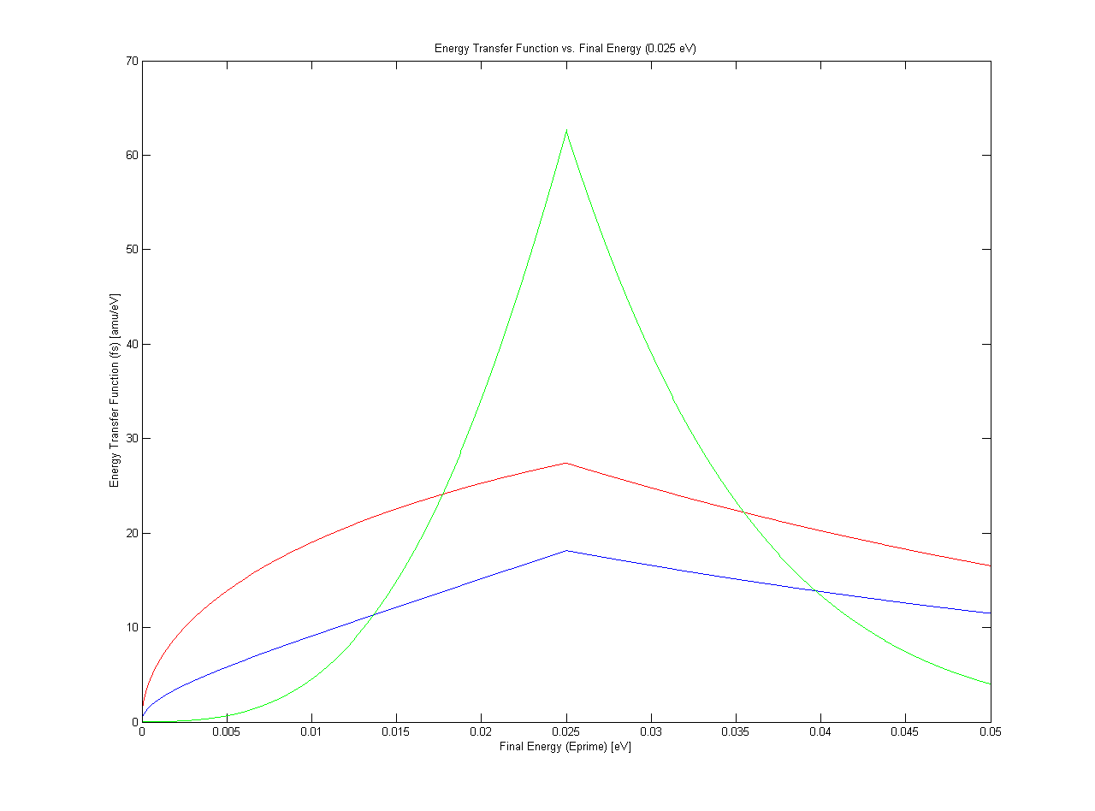

Figure Energy Transfer function vs Final Energy (0.025 eV)

* 1. 10 eV

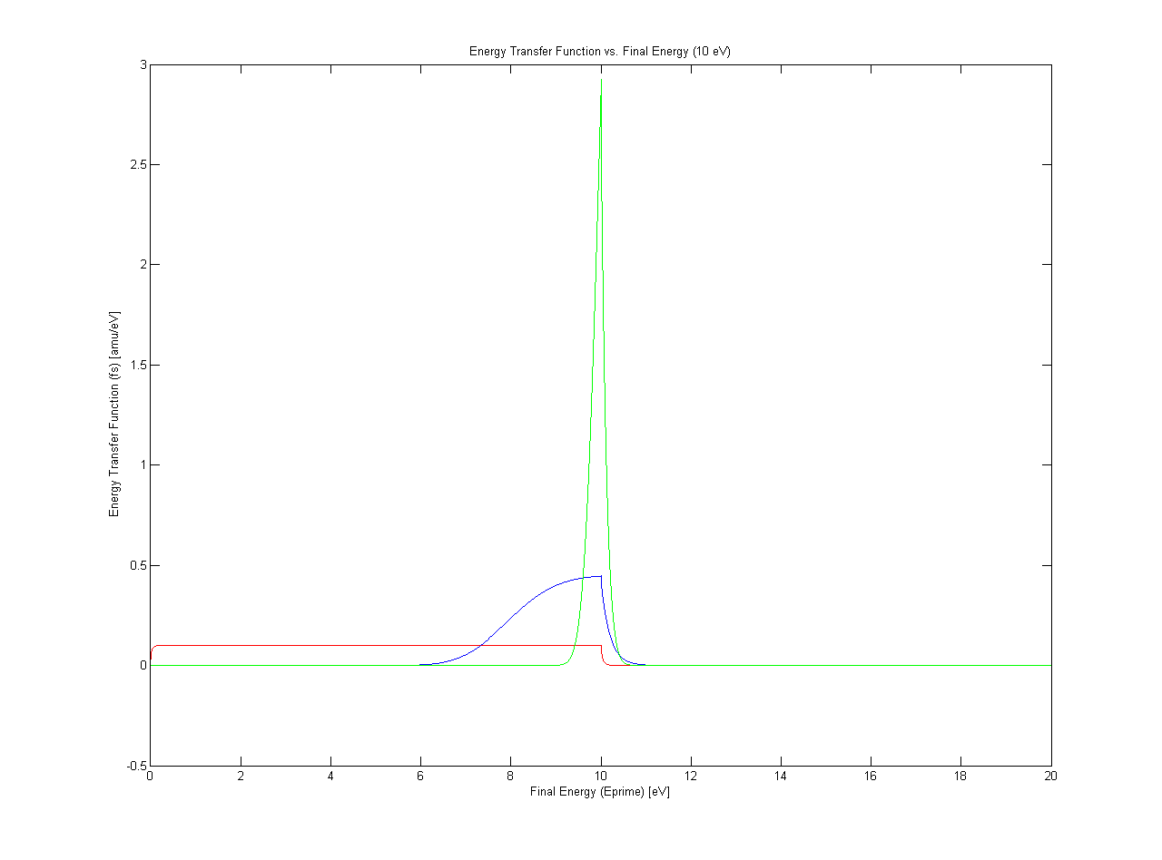

Figure Energy Transfer function vs Final Energy (10 eV)

* 1. 100 eV

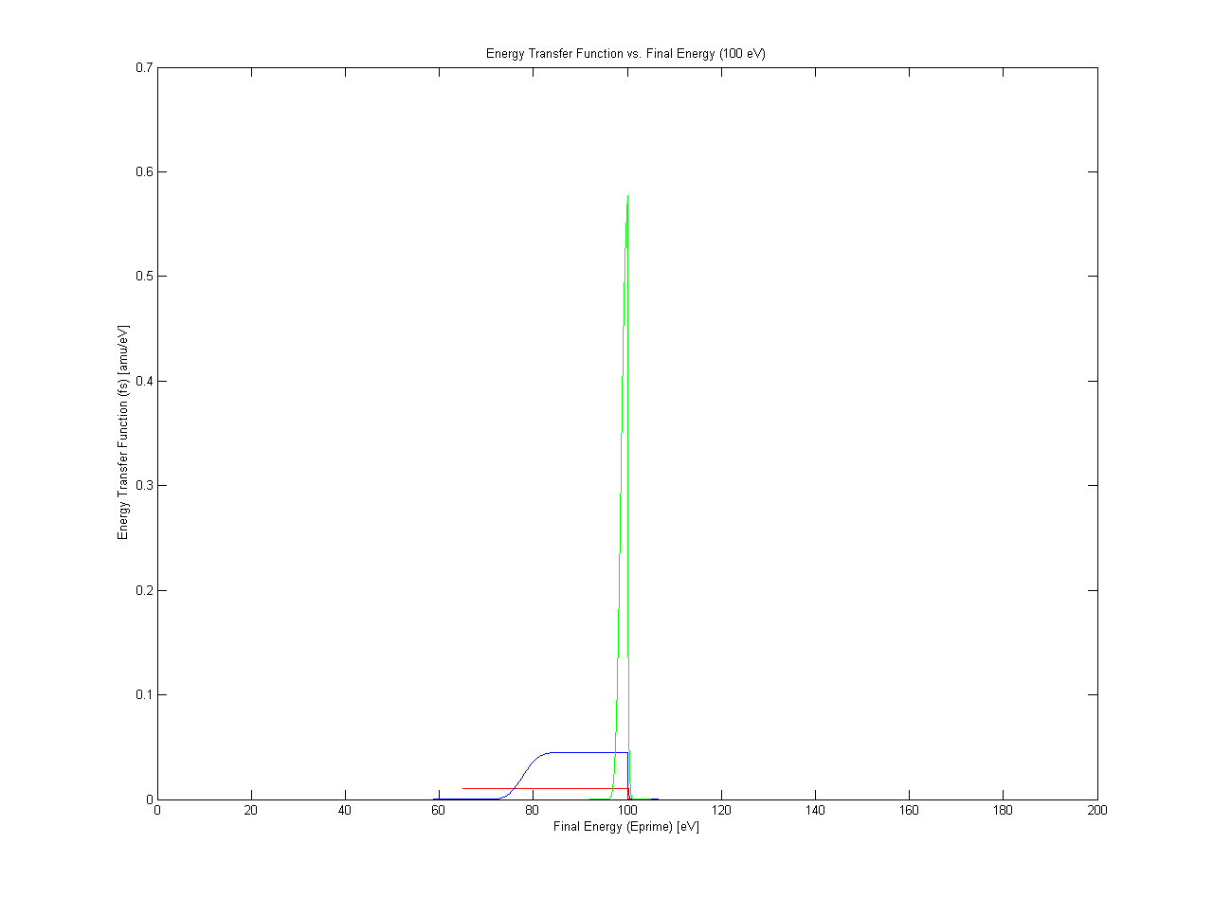

Figure Energy Transfer function vs Final Energy (100 eV)

Code:

function [etfunction,energy]=swavescattering(E,A,T)

res=2\*E/1000;

k=8.6173E-5; %boltzmann's constant in eV/K

T=T+273.15; %conversion to kelvins

etfunctionfirsthalf=[]; %initializing constants

etfunctionsecondhalf=[];

energyfirsthalf=[];

energysecondhalf=[];

eta=((A+1)/(2\*sqrt(A))); %eta and rho from definitions in assignment

rho=(A-1)/(2\*sqrt(A));

for eprime=0:res:E %E'<E case fs calculation (appending to vector to plot)

fs=((eta^2)/(2\*E))\*(erf((eta\*sqrt(eprime/(k\*T)))-rho\*sqrt(E/(k\*T)))+(erf((eta\*sqrt(eprime/(k\*T)))+rho\*sqrt(E/(k\*T))))+exp((E-eprime)/(k\*T))\*(erf((eta\*sqrt(E/(k\*T)))-rho\*sqrt(eprime/(k\*T)))-(erf((eta\*sqrt(E/(k\*T)))+rho\*sqrt(eprime/(k\*T))))));

etfunctionfirsthalf=[etfunctionfirsthalf,fs];

energyfirsthalf=[energyfirsthalf,eprime];

end

for eprime=E:res:2\*E %E'>E case fs calculation (appending to vector to plot)

fs=((eta^2)/(2\*E))\*(erf((eta\*sqrt(eprime/(k\*T)))-rho\*sqrt(E/(k\*T)))-(erf((eta\*sqrt(eprime/(k\*T)))+rho\*sqrt(E/(k\*T))))+exp((E-eprime)/(k\*T))\*(erf((eta\*sqrt(E/(k\*T)))-rho\*sqrt(eprime/(k\*T)))+(erf((eta\*sqrt(E/(k\*T)))+rho\*sqrt(eprime/(k\*T))))));

etfunctionsecondhalf=[etfunctionsecondhalf,fs];

energysecondhalf=[energysecondhalf,eprime];

end

energy = [energyfirsthalf,energysecondhalf]; %concatenating vectors

etfunction = [etfunctionfirsthalf,etfunctionsecondhalf];